April 2017

Renishaw’s RA802 Pharmaceutical Analyser wins an award
Renishaw, the global engineering technologies company, is delighted to announce that its RA802 Pharmaceutical Analyser has won the best measurement laboratory equipment award during Eurolab 2017. The new RA802 is a compact benchtop Raman imaging system, designed exclusively for the pharmaceutical industry.
EuroLab 2017, now in its 19th year, successfully combines the worlds of science and industry. EuroLab is the only trade show event in Poland dedicated to the laboratory industry; it’s an invaluable source of information and knowledge surrounding state-of-the-art research methods and scientific techniques. The judges commented “We had very strong competition for this award but wanted to show with our decision that small could be beautiful! The compact RA802 Pharmaceutical Analyser system wowed us during the presentation, with its high quality, accuracy and speed of mapping, as well as ease of use and powerful data analysis software.”
The RA802 enables users to formulate tablets more efficiently by speeding up the analysis of tablet composition and structure. It brings together the chemical analysis power of Raman spectroscopy and advanced imaging technologies in a powerful, robust system. Users can reveal detailed chemical and physical information about the contents of their sample, from the distribution and size of API domains to the physical topography. The RA802 makes the highest performance Raman spectroscopy accessible to all users.
Please visit www.renishaw.com/RA802 for further details about Renishaw's RA802 Pharmaceutical Analyser.
-ENDS-

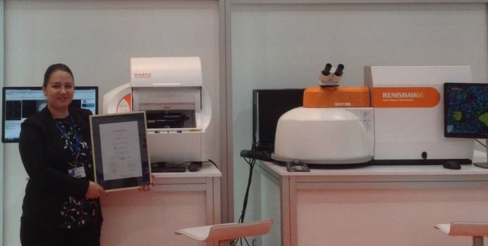
Image: Agnieszka Sozańska, Sales Manager for Poland, with Renishaw’s award winning RA802 Pharmaceutical Analyser and inVia Raman system.

About Renishaw

Renishaw is one of the world's leading engineering and scientific technology companies, with expertise in precision measurement and healthcare. The company supplies products and services used in applications as diverse as jet engine and wind turbine manufacture, through to dentistry and brain surgery. It is also a world leader in the field of additive manufacturing (also referred to as 3D printing), where it is the only UK business that designs and makes industrial machines which ‘print' parts from metal powder.

The Renishaw Group currently has more than 70 offices in 35 countries, with over 4,000 employees, of which 2,700 people are employed within the UK. The majority of the company's R&D and manufacturing is carried out in the UK and for the year ended June 2016 Renishaw achieved sales of £436.6 million of which 95% was due to exports. The company's largest markets are the China, USA, Germany and Japan.

The Company's success has been recognised with numerous international awards, including eighteen Queen's Awards recognising achievements in technology, export and innovation. Renishaw received a Queen’s Award for Enterprise 2014, in the Innovations category, for the continuous development of the inVia confocal Raman microscope. For more information visit www.renishaw.com

For further information

Please contact:
David Reece
Renishaw plc
New Mills
Wotton-under-Edge
Gloucestershire GL12 8JR UK
Tel: +44 1453 523968 (direct)
Tel: +44 1453 524524 (switchboard)
Fax: +44 1453 523901
Email: david.reece@renishaw.com
www.renishaw.com/raman

