14th July 2016
Renishaw’s inVia™ confocal Raman microscope is used to study blood stored in plastic blood bags
The Michael Smith Laboratories at the University of British Columbia in Vancouver, Canada, is leading the way in the use of Raman spectroscopy as a tool for monitoring biochemical changes and inter-donor variability in stored red blood cell (RBC) units^{1,2}. The research group of Professors Michael Blades and Robin Turner recently published this work in the Analyst.
For this work the group collaborated with Canadian Blood Services, using Raman microspectroscopy (RMS) to investigate the chemical changes that occur in red blood cells (RBCs), during storage in bags, which could eventually be used as a quality check prior to transfusion. The group illustrated how the inVia could be used to analyse bulk properties of a sample, both in a conventional microscopy mode, and with a laser offset by using the inVia’s software controlled beam steering capabilities. The laser and collection optics were purposely aligned to implement a spatially-offset Raman spectroscopy (SORS) measurement at a set position, enabling analysis of the blood with minimal interference from the bag material.
In addition, the group study bio-analytical applications with RMS, in particular spatially resolved analyses using the Renishaw inVia. To date, it has used RMS to characterise single cells and populations of cells in vitro as they respond to a variety of chemical and environmental stimuli, including those triggering differentiation, autophagy, necrosis and apoptosis. It also uses RMS for the sub-cellular analyses of glycogen and nucleoli.
The group has worked with Renishaw since the late 1990s when it used an RM-1000 system which “performed flawlessly and served as a workhorse for many years.” Describing the more recent instrumental developments, Professor Turner said, “In 2009 we traded that system for a refurbished inVia platform in order to take advantage of the StreamLine™ mapping technology and, in 2015, purchased a new inVia system. We now have two inVia systems operating in our lab and both are heavily used—mainly by us—but also by a growing number of external users on a fee-for-use basis. The robustness and ease of use of the inVia make it feasible to quickly train some of the more frequent external users so they can do their measurements without our personnel standing by.
He continued, “Our dealings with Renishaw have been a very positive experience. The StreamLine feature is very useful to us and the WiRE software is powerful and easy to use. We have also been very happy with the service and support that we have received from Renishaw and ProSpect Scientific (Renishaw's Canadian representative). The platform is flexible and we have exploited that to, for example, implement a fluorescence imaging microscopy system that uses the same microscope and hence can be used to image the same sample by fluorescence and Raman, and to implement SORS.”
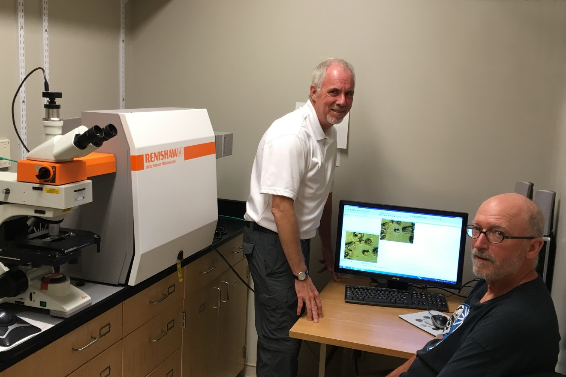
Please visit www.renishaw.com/bio for further details on how Renishaw’s inVia confocal Raman microscope is being used in the life sciences.
Image: Professors Michael Blades and Robin Turner from the University of British Columbia in Vancouver, Canada, with their Renishaw inVia confocal Raman microscope
References
^{1.} K. Buckley, C.G. Atkins, D. Chen, H.G. Schulze, D.V. Devine, M.W. Blades, R.F.B. Turner "Non-invasive Spectroscopy of Transfusable Red Blood Cells Stored Inside Sealed Plastic Blood-Bags", Analyst 141, 1678-1685, 2016 DOI: 10.1039/C5AN02461G
^{2.} C.G. Atkins, K. Buckley, D. Chen, H.G. Schulze, D.V. Devine, M.W. Blades and R.F.B. Turner, "Raman spectroscopy as a novel tool for monitoring biochemical changes and inter-donor variability in stored red blood cell units ", Analyst 141, 3319-3327, 2016. DOI: 10.1039/C6AN00373G
-Ends-
About Renishaw
Renishaw is one of the world's leading engineering and scientific technology companies, with expertise in precision measurement and healthcare. The company supplies products and services used in applications as diverse as jet engine and wind turbine manufacture, through to dentistry and brain surgery. It is also a world leader in the field of additive manufacturing (also referred to as 3D printing), where it is the only UK business that designs and makes industrial machines which ‘print' parts from metal powder.
The Renishaw Group currently has more than 70 offices in 35 countries, with over 4,000 employees, of which 2,700 people are employed within the UK. The majority of the company's R&D and manufacturing is carried out in the UK and for the year ended June 2015 Renishaw achieved sales of £494.7 million of which 95% was due to exports. The company's largest markets are the USA, China, South Korea, Germany and Japan.
The Company's success has been recognised with numerous international awards, including eighteen Queen's Awards recognising achievements in technology, export and innovation. Renishaw received a Queen’s Award for Enterprise 2014, in the Innovations category, for the continuous development of the inVia confocal Raman microscope. For more information, visit www.renishaw.com

For further information
Please contact:
David Reece
Renishaw plc
New Mills
Wotton-under-Edge
Gloucestershire GL12 8JR UK
Tel: +44 1453 523968 (direct)
Tel: +44 1453 524524 (switchboard)
Fax: +44 1453 523901
Email: david.reece@renishaw.com
www.renishaw.com/raman

