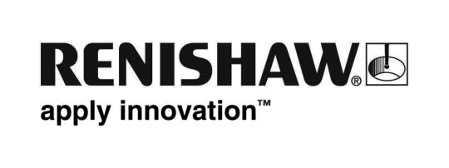
July 2016 Enquiries: Chris Pockett, Head of Communications (+44 1453 524133)

Renishaw hosts inaugural South Wales Greenpower event

Global engineering company Renishaw hosted the first South Wales Greenpower event at its Miskin site on July 2nd, 2016, which saw teams competing in the IET Formula Goblin category for primary school children. Greenpower racing events encourage young people to take an interest in engineering in a fun and innovative way by building and racing a fully functional electric car.

The South Wales event saw twelve brand new teams competing in the Goblins category (ages 9-11) at Renishaw’s Miskin site. This year’s overall winners were YGG Tonyrefail with the team Mellten Ton, who won the slalom category and snatched third place in both the drag and sprint races.

Renishaw has been involved with registered charity Greenpower as a sponsor for ten years, historically supporting the events held at Castle Combe for secondary schools and students in further education. Renishaw has also hosted Greenpower races at its New Mills headquarters for a number of years. The in-house Renishaw teams that participate in the further education (F24+ category) and corporate challenge have had excellent results so far, winning both championships in 2015.

“We have firsthand evidence that Greenpower is a fun and meaningful experience that gets young people interested in engineering,” explained Julie Collins, Education Liaison Manager of Renishaw. “In fact, a number of our apprentices participated in a Greenpower event when they were at school. Hosting the event in South Wales extended the reach of the positive work Greenpower does. By next year, we hope to double the number of entrants in Wales and encourage even more participants and local companies to get involved.”

“Without Renishaw’s support and the commitment of its dedicated volunteers on the day, the event in South Wales would not have been possible,” explained Jeremy Way, CEO of Greenpower. “Our relationship with Renishaw has been growing stronger over the years – it’s encouraging to see a global engineering company that really believes in our mission to inspire and excite young people into STEM careers.”

Greenpower was established in 1999 with the mission to inspire young people into careers in STEM subjects, using motorsport as a hook to engage students and young adults to participate.

The project requires entrant teams to build a driveable electric car, it develops on the school curriculum and stimulates learning in electricity, materials, maths, design and technology.

The students work as part of a team to raise funds to build the cars, a process that often involves writing to local companies for fundraising. The event has seen a year-on-year increase of engagement among young people, especially girls.

Renishaw is a global engineering company supplying products to a wide range of industries for applications from brain surgery to jet engines.

Ends 445 words
Notes to editors
UK-based Renishaw is a world leading engineering technologies company, supplying products used for applications as diverse as jet engine and wind turbine manufacture, through to dentistry and brain surgery. It has over 4,000 employees located in the 35 countries where it has wholly owned subsidiary operations.

For the year ended June 2016 Renishaw recorded sales of £436.6 million of which 95% was due to exports. The company’s largest markets are China, the USA, Japan and Germany.

Throughout its history Renishaw has made a significant commitment to research and development, with historically between 14 and 18% of annual sales invested in R&D and engineering. The majority of this R&D and manufacturing of the company’s products is carried out in the UK.

The Company’s success has been recognised with numerous international awards, including eighteen Queen’s Awards recognising achievements in technology, export and innovation.

Renishaw is listed on the London Stock Exchange (LSE:RSW) where it is a constituent of the FTSE 250, with a current valuation of around £1.8 billion.

Further information at www.renishaw.com

