1st March 2016
The world-renowned Memorial Sloan Kettering Cancer Center in New York City uses a Renishaw inVia confocal Raman microscope, in the Kircher Laboratory, to support the development of nanomolecular probes.
The Kircher laboratory at Memorial Sloan Kettering is developing novel nanoprobes for molecular imaging, image-guided therapy and theranostics. Its ultimate goal is to develop a universal technology that allows precise determination of the actual spread of a tumour in vivo. Currently, surgeons cannot see the microscopic extent of the tumour during a procedure, which is essential information for tumor removal and avoiding excess tissue excision.
Physician-scientist Dr. Moritz Kircher is working on a new generation of nanometer-sized imaging beacons. These allow detection, during surgeries and minimally invasive procedures, of the macroscopic extent of the primary tumour, its true microscopic spread, as well information on satellite micrometastases. These nanobeacons can be located using surface enhanced resonance Raman scattering (SERRS), which can be combined with other whole-body imaging methods, such as magnetic resonance imaging (MRI) or positron emission tomography (PET).
SERRS is a highly sensitive technique utilising a resonance Raman effect, combined with a surface enhancement obtained from nanoparticles to give dramatic enhancements to the normally weak Raman signal. The advantages of the SERRS method are also utilised by Renishaw Diagnostics in their recently launched CE certified RenDX Fungiplex assay IVD device.
Dr. Kircher is a member of the Department of Radiology, the Center for Molecular Imaging and Nanotechnology and the Brain Tumor Center. He chose the Renishaw inVia confocal Raman microscope for the Kircher Laboratory, following his positive experience of using the instrument—and the successful research he obtained—during his post-doctoral studies at Stanford University, in the group of Professor Sam Gambhir. He has gone on to publish several high profile papers using inVia’s results.¹ Dr. Kircher said, “Our aims are to visualise any cancer type with the ultrasensitive Raman nanostar particles my group has developed. This includes providing high precision intraoperative guidance to surgeons, so that they can, with confidence, visualise and excise all cancer cells completely and without having to sacrifice too much normal tissue around the tumour. In addition, our SERRS nanoparticles are not only universal with regards to tumour type, they also allow us to detect microscopic tumour extensions from the main tumour into the periphery, microscopic loco regional metastases and even premalignant lesions.”
Most recently, the group has published an overview paper in the Journal of Nuclear Medicine², which cites SERRS as a new modality for cancer imaging. The authors concluded that the increased accuracy in visualising the full extent of tumour spread provided by the SERRS signal could increase the precision with which cancers can be resected or destroyed, be it via open surgery or minimally invasive techniques used by interventional radiologists. With the application of SERRS in diagnostics and cancer detection the future for the application of Raman spectroscopy in this field looks very promising.
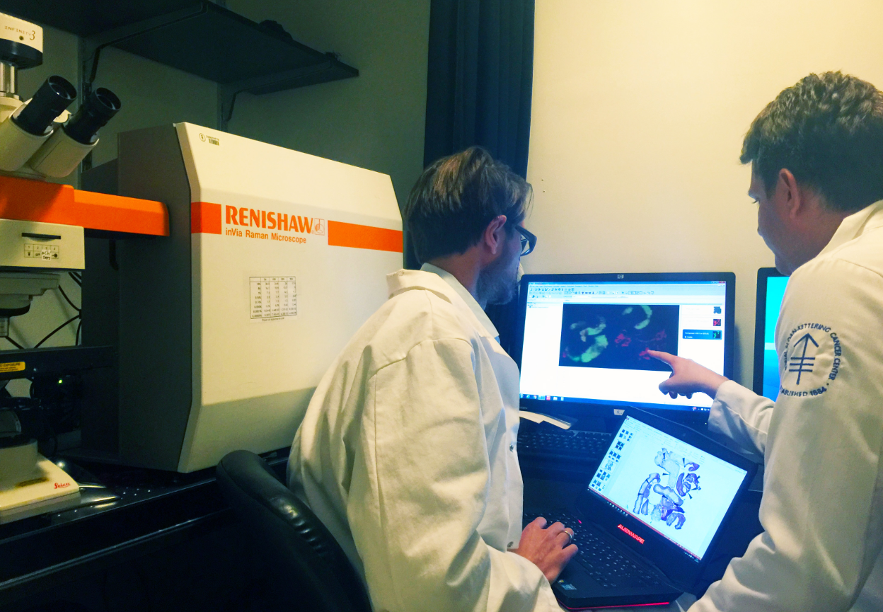
For further details about Renishaw’s inVia confocal Raman microscope, visit www.renishaw.com/inVia.
Image: Postdoctoral fellow, Anton Oseledchyk, MD, with head of the laboratory, Dr Moritz Kircher, of Memorial Sloan Kettering Cancer Center with their Renishaw inVia Raman microscope.
References
¹ Surface-enhanced resonance Raman scattering nanostars for high-precision cancer imaging, Harmsen et al, Science Translational Medicine 21 Jan 2015: Vol. 7, Issue 271, pp. 271ra7, DOI: 10.1126/scitranslmed.3010633
² Surface-Enhanced Raman Spectroscopy: A New Modality for Cancer Imaging, Andreou, Kishore & Kircher, J Nucl Med 2015; 56:1–5, DOI: 10.2967/jnumed.115.158196
-Ends-
About Renishaw
Renishaw is one of the world's leading engineering and scientific technology companies, with expertise in precision measurement and healthcare. The company supplies products and services used in applications as diverse as jet engine and wind turbine manufacture, through to dentistry and brain surgery. It is also a world leader in the field of additive manufacturing (also referred to as 3D printing), where it is the only UK business that designs and makes industrial machines which ‘print' parts from metal powder.
The Renishaw Group currently has more than 70 offices in 33 countries, with over 4,000 employees, of which 2,700 people are employed within the UK. The majority of the company's R&D and manufacturing is carried out in the UK and for the year ended June 2015 Renishaw achieved sales of £494.7 million of which 95% was due to exports. The company's largest markets are the USA, China, South Korea, Germany and Japan.
The Company's success has been recognised with numerous international awards, including eighteen Queen's Awards recognising achievements in technology, export and innovation. Renishaw received a Queen’s Award for Enterprise 2014, in the Innovations category, for the continuous development of the inVia confocal Raman microscope. For more information visit www.renishaw.com

For further information
Please contact:
David Reece
Renishaw plc
New Mills
Wotton-under-Edge
Gloucestershire GL12 8JR UK
Tel: +44 1453 523968 (direct)
Tel: +44 1453 524524 (switchboard)
Fax: +44 1453 523901
Email: david.reece@renishaw.com
www.renishaw.com/raman

