20th May 2016
Raman spectroscopy used to detect radiation damage in cells and tissues during cancer treatment at the University of British Columbia in Okanagan, Canada
The Irving K Barber School of Arts and Sciences at the University of British Columbia, Canada, hosts a multidisciplinary group of physics, engineering and radiation oncology scientists. It is interested in detecting and understanding the damage in cells and tissues caused by ionizing radiation used in cancer treatments. Currently the radiation dose a patient receives is prescribed based on population averages and does not take the individual patient’s radio sensitivity into account. The ultimate aim of the group is to help personalise prescriptions based on an individual’s response to radiation.
In some cases, it is possible to use Raman spectroscopic techniques to detect radiation damage in patients. The group is conducting research to find out if it is possible to make an early detection tool based on Raman spectroscopy, either prior to first treatment or within the first few fractions of treatment.
Associate Professor Andrew Jirasek is a physicist by training who has specialised in accurately measuring radiation treatments for cancer patients. Together with his colleagues, Dr. Jirasek was the first to apply Raman spectroscopy to look at the unique cellular changes that occur following radiation. He says. “This is a very powerful technique. We can record and analyse information about how the molecules and cellular constituents change throughout treatment.” Dosage can then be adjusted to be more precise and targeted. He continues, “Previously, the only outcome of treatment was disease status; for example, tumour size. Our hope is that Raman analysis will provide accurate treatment evaluation sooner. Like many other diseases, timing with cancer treatment is everything. The sooner successful therapy is implemented, the better for the patient.” After conducting cell and animal model experiments, the group is now about to test the system on prostate cancer patients.
Describing the choice of the Renishaw inVia Raman microscope for this work, Dr. Jirasek said, “We chose the inVia for multiple reasons. The system delivers excellent Raman sensitivity and throughput. It also offers us high potential for automation. Because the system is used by multiple groups and types of users, ease of use is important to maximise our ‘up time’. With several users not being experts in Raman, we have appreciated the excellent customer service support we have had from Renishaw.”
Dr. Jirasek’s work has been well reported and has recently appeared in several publications as well as presentations at conferences. Notable among these include ‘A Raman spectroscopic study of cell response to clinical doses of ionizing radiation’¹ and ‘Raman spectroscopy identifies radiation response in human non-small cell lung cancer xenografts’². Full details of this research program and publications may be viewed at Dr. Jirasek’s homepage: http://medicalphysics.ok.ubc.ca/faculty/jirasek.html
Please visit www.renishaw.com/bio for further details on how Renishaw’s inVia confocal Raman microscope is being used in the life sciences.
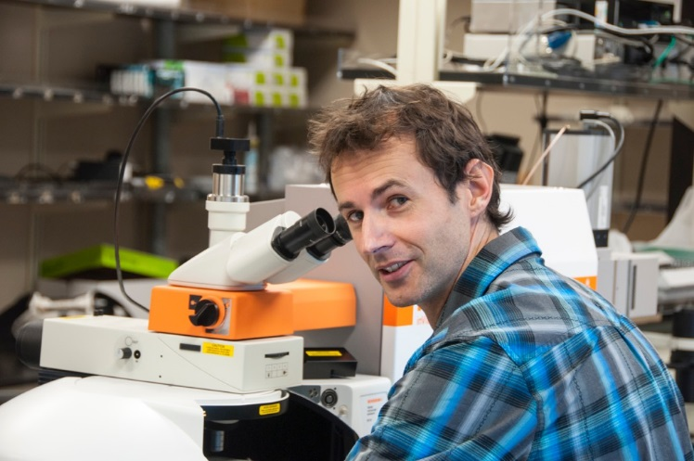

Image: Dr. Andrew Jirasek from the University of British Columbia in Okanagan, Canada, with his Renishaw inVia Raman microscope.
References
^{1.} Harder et al: A Raman Spectroscopic Study of Cell Response to Clinical Doses of Ionizing Radiation: Applied Spectroscopy: Volume 69, Number 2, 2015.
^{2.} Harder et al: Raman spectroscopy identifies radiation response in human non-small cell lung cancer xenografts; Scientific Reports; 6:21006, DOI: 10.1038/srep21006.
-Ends-
About Renishaw
Renishaw is one of the world's leading engineering and scientific technology companies, with expertise in precision measurement and healthcare. The company supplies products and services used in applications as diverse as jet engine and wind turbine manufacture, through to dentistry and brain surgery. It is also a world leader in the field of additive manufacturing (also referred to as 3D printing), where it is the only UK business that designs and makes industrial machines which ‘print' parts from metal powder.
The Renishaw Group currently has more than 70 offices in 35 countries, with over 4,000 employees, of which 2,700 people are employed within the UK. The majority of the company's R&D and manufacturing is carried out in the UK and for the year ended June 2015 Renishaw achieved sales of £494.7 million of which 95% was due to exports. The company's largest markets are the USA, China, South Korea, Germany and Japan.
The Company's success has been recognised with numerous international awards, including eighteen Queen's Awards recognising achievements in technology, export and innovation. Renishaw received a Queen’s Award for Enterprise 2014, in the Innovations category, for the continuous development of the inVia confocal Raman microscope. For more information visit www.renishaw.com

For further information
Please contact:
David Reece
Renishaw plc
New Mills
Wotton-under-Edge
Gloucestershire GL12 8JR UK
Tel: +44 1453 523968 (direct)
Tel: +44 1453 524524 (switchboard)
Fax: +44 1453 523901
Email: david.reece@renishaw.com
www.renishaw.com/raman

